**Assignment: Module 2 (CSS & CSS3)**

**Que.1** **What are the benefits of using CSS?**

**Ans.1** There are several below listed advantage of CSS.

**1.Responsive website:** with the help of CSS, you can create responsive web designs that adapt to different screen sizes and devices. This is crucial in the era of mobile browsing, as it ensures your website looks and functions well on various platforms.

**2.Faster Loading Time:** External CSS files can be cached by web browsers, allowing them to load faster on subsequent visits.

**3.Consistancy:** CSS enables consistent styling across an entire website or multiple pages. By creating a single external CSS file and linking it to multiple web pages, you ensure a uniform look and feel. This reduces redundancy and makes it easier to update styling elements globally.

**4.Seperation of Content & Style:** most significant advantages of CSS is its ability to separate content from presentation. This separation enhances the maintainability of web pages as changes to the styling can be made without altering the underlying HTML structure.

**5.Globle Styling:** External CSS files can be linked to multiple web pages, making it easy to apply consistent styling across an entire website. This saves time and ensures a cohesive design

**6.Accessibilty:**it allows to improve accessibility by controlling the presentation.

**Que.2 What are the disadvantages of CSS?**

**Ans.2** CSS also have some disadvantages that are listed below:

**1.Lack of Security:** CSS itself does not offer security features, and it can be vulnerable to attacks like Cross-Site Scripting when used inappropriately. Developers must be cautious when implementing CSS to prevent security risks.

**2.Browser Compatibility:** CSS may render differently in various web browsers, leading to inconsistencies in the visual presentation. We need to write browser-specific CSS code or use vendor prefixes to ensure compatibility.

**3.Performance Impact:** Extensive or poorly optimized CSS files can slow down page load times. It's essential to minimize and optimize CSS to maintain optimal website performance.

**4.Overriding Style:** The "cascading" nature of CSS can sometimes lead to unexpected styling conflicts. Specificity and the order in which styles are applied can result in unintended consequences.

**Que.3 What is the difference between CSS2 and CSS3?**

**Ans.3** **CSS:** Its main objective is to provide styling and fashion to the web page.

**CSS3:** it is the advanced version of CSS. It is used for structuring, styling, and formatting web pages.

|  |  |  |
| --- | --- | --- |
| **Sr.No** | **CSS** | **CSS3** |
| 1 | CSS was developed in 1996. | CSS3 is the latest version of CSS and was released in 2005. |
| 2 | Responsive designing is not supported in CSS | CSS3 is the latest version, hence it supports responsive design. |
| 3 | CSS cannot be split into modules. | CSS3 can be breakdown into modules. |
| 4 | set of standard colors and it uses basic color schemes only. | CSS3 has a good collection of HSL RGBA, HSLA, and gradient colors. |
| 5 | CSS does not support media queries. | But CSS3 supports media queries |
| 6 | In CSS, we have to manually develop rounded gradients and corners. | But CSS3 provides advanced codes for setting rounded gradients and corners |
| 7 | There is no special effect like shadowing text, text animation, etc. in CSS. The animation was coded in jQuery and JavaScript. | CSS3 has many advance features like text shadows, visual effects, and a wide range of font styles and colors. |
| 8 | In CSS, the user can add background colors to list items and lists, set images for the list items, etc. | Whereas CSS3 list has a special display property defined in it. Even list items also have counter reset properties. |

**Que.4 Name a few CSS style components**

**Ans.4** CSS style consists of several components that define how an HTML element should be visually presented on a web page. These components work together to create the desired appearance of web content. The main components of a CSS style include:

1. **Selector:** Selectors are used to target specific HTML elements to which the style will be applied. CSS selectors can target elements by their HTML tag name (element selectors), class names (class selectors), IDs (ID selectors), attributes, and more.

**Example selectors:**

- Element selector: p{ ... }

- Class selector: .my-class { ... }

- ID selector: #my-id { ... }

1. **Properties:** Properties are the individual style attributes that you want to set for the selected elements. Each property corresponds to a specific aspect of an element's appearance, such as color, font size, margin, padding, or border.

**Example properties:**

- color: Sets the text color.

- font-size: Defines the font size.

- margin: Specifies the margin around an element.

- padding: Sets the padding inside an element.

- border: Controls the border of an element.

1. **Values:** Values are the settings or values you assign to CSS properties. Values can be specific, relative, or keyword-based..

**Example values:**

- 12px: A specific pixel size.

- red: A specific color.

- 1em: Relative size based on the element's font size.

- left: A keyword value indicating alignment.

1. **Declaration Block:** A declaration block is a set of one or more property-value pairs enclosed within curly braces {}. Each property-value pair is separated by a semicolon ;.

**Example declaration block:**

p {

color: blue;

font-size: 16px;

}

1. **Rule Set:** A rule set is a complete CSS rule that consists of a selector and its associated declaration block. It defines which HTML elements should be styled and how they should be styled.

Example rule set:

p {

color: blue;

font-size: 16px;

}

1. **Stylesheet:** A stylesheet is a collection of CSS rule sets. Stylesheets can be included in an HTML document using the <link> element (external stylesheet) or within a <style> element in the HTML <head> section (internal stylesheet).

By combining these components, you can create sophisticated and customized styles to control the visual presentation of HTML elements on your web page.

**Que.5 What do you understand by CSS opacity?**

**Ans.5** The **opacity** in CSS is the property of an element that describes the transparency of the element. It is the opposite of transparency & represents the degree to which the content will be hidden behind an element. We can apply the opacity with different styling properties to the elements.

**Image Opacity:** The opacity property is used in the image to describe the transparency of the image. The value of opacity lies between 0.0 to 1.0 where a low value represents high transparency and a high value represents low transparency. The percentage of opacity is calculated as Opacity% = Opacity * 100.

**Example:**

<style>

img {

opacity: 0.5;

}

</style>

**Que.6 How can the background color of an element be changed?**

**Ans.6** The [background-color property](https://www.geeksforgeeks.org/css-background-color-property/) of CSS is used to set the background of an element. We can set background color by selecting the element by its class name of id name and then apply the background-color property on it to set the background color.

<!DOCTYPE html>

<html lang="en">

<head>

    <style>

        div {

            margin: 50px 50px;

            font-size: 50px;

        }

        .back1 {

            background-color: rgb(141, 58, 130);

        }

        .back2 {

            background-color: rgb(161, 132, 37);

            color: black;

        }

        .back3 {

            background-color: rgb(67, 163, 67);

        }

    </style>

</head>

<body>

    <div class="back1">

        First Element color

    </div>

    <div class="back2">

        gSecond Element color

    </div>

    <p class="back3" style="margin:50px 50px; font-size: 50px;">

        Third Element color

    </p>

</body>

</html>

**Que.7 How can image repetition of the backup be controlled?**

**Ans.7** The **background-repeat property** in CSS is used to repeat the background image both horizontally and vertically. It also decides whether the background image will be repeated or not.

**Example 1:**  use of the repeat-x to repeat the image in the horizontal direction.

<html>

<head>

    <title>background-repeat property</title>

    <style>

        body {

            margin-top: 40px;

            background-image: url("nature.jpg");

            background-repeat: repeat-x;

            background-size: 150px 100px;

        }

        h1 {

            text-align: center

        }

    </style>

</head>

<body>

    <h1>Nature Image</h1>

</body>

</html>

**Example 2:** use of the repeat-y to repeat the image in the vertical direction.

<!DOCTYPE html>

<html>

<head>

    <title>background-repeat property</title>

    <style>

        body {

            margin-top: 40px;

            background-image: url("nature.jpg");

            background-repeat: repeat-y;

            background-size: 150px 100px;

        }

        h1 {

            text-align: center

        }

    </style>

</head>

<body>

    <h1>Nature Image</h1>

</body>

</html>

**Example 2: use of no repeat, Image is didn’t repeat.**

<!DOCTYPE html>

<html>

<head>

    <title>background-repeat property</title>

    <style>

        body {

            margin-top: 40px;

            background-image: url("nature.jpg");

            background-repeat: no-repeat;

            background-size: 150px 100px;

        }

        h1 {

            text-align: center

        }

    </style>

</head>

<body>

    <h1>Nature Image</h1>

</body>

</html>

**Que.8 What is the use of the background-position property?**

**Ans.8** The background-position property sets the starting position of a background image.

<!DOCTYPE html>

<html>

<head>

<style>

#myDIV {

  height:200px;

  border: 10px dashed black;

  padding: 25px;

  background-attachment: fixed;

  background-position: center;

  background-image: url(nature.jpg);

}

</style>

</head>

<body>

<h1>The background-position Property</h1>

<div id="myDIV">

Example of background Position</div>

</body>

</html>

**Que.9 Which property controls the image scroll in the background?**

**Ans.9** The [**background-attachment**](https://www.geeksforgeeks.org/css-background-attachment-property/) property in CSS is used to specify the kind of attachment of the background image with respect to its container. It can be set to scroll or make it remain fixed.

Syntax: background-attachment:scroll|fixed|local|initial|inherit;

Example: background-image will scroll with the page (scroll).

<!DOCTYPE html>

<html>

<head>

    <style>

        #example {

                background-image: url(nature.jpg);

                background-position: center;

                background-repeat: no-repeat;

                background-attachment: scroll;

        }

    </style>

</head>

<body style="text-align:center">

    <h1 style="color:green">GeeksforGeeks</h1>

    <h2> background-attachment: scroll;</h2><br><br>

    <div id="example">

        <p>

            Nature can refer to the general realm of

            living plants and animals,

            and in some cases to the processes

            associated with inanimate objects—the

            way that particular types of things exist

            and change of their own accord,

            such as the weather and geology of the Earth.

       </p>

      </div>

</body>

</html>

Example: background-image will not scroll with the page, I will fixed.

<!DOCTYPE html>

<html>

<head>

    <style>

        #example {

                background-image: url(nature.jpg);

                background-position: center;

                background-repeat: no-repeat;

                background-attachment: fixed;

        }

    </style>

</head>

<body style="text-align:center">

    <h1 style="color:green">GeeksforGeeks</h1>

    <h2> background-attachment: scroll;</h2><br><br>

    <div id="example">

        <p>

            Nature can refer to the general realm of

            living plants and animals,

            and in some cases to the processes

            associated with inanimate objects—the

            way that particular types of things exist

            and change of their own accord,

            such as the weather and geology of the Earth.

       </p>

      </div>

</body>

</html>

**Que.10 Why should background and color be used as separate properties?**

**Ans.10** background-color sets the background color and color sets text color.

**Que.11 How to center block elements using CSS1?**

**Ans.11** with the help of margin property, we can center the block element:

Example:

<!DOCTYPE html>

<html lang="en">

<head>

    <meta charset="UTF-8" />

    <meta http-equiv="X-UA-Compatible" content="IE=edge" />

    <meta name="viewport" content="width=device-width, initial-scale=1.0" />

    <style>

        header {

            font-size: 20px;

            margin: auto;

            width: 30%;

            background-color: lightgreen;

            margin-bottom: 10px;

        }

        p {

            display: inline-block;

        }

        img {

            display: block;

            margin: auto;

        }

    </style>

</head>

<body>

    <header>

        centering image using display: block

    </header>

    <img src= "nature.jpg" alt="image here" width="500" height="400" />

    <p>

        Nature can refer to the general realm of

        living plants and animals,

        and in some cases to the processes

        associated with inanimate objects the

        way that particular types of things exist

        and change of their own accord,

        such as the weather and geology of the Earth.

    </p>

</body>

</html>

**Que.12 How to maintain the CSS specifications?**

**Ans.12** CSS specifications are maintained by the [World Wide Web Consortium](http://www.w3.org/) (W3C). Even though every browser supports CSS, there are many inconsistencies in the supported specification version. Some browsers even have their own implementation of the specification and have proprietary (vendor) prefixes.

**Que.13 What are the ways to integrate CSS as a web page?**

**Ans.13** There are three ways to integrate CSS as a web page:

**1.Inline CSS**: We can apply CSS in a single element by inline CSS technique. The inline CSS is also a method to insert style sheets in HTML document. If you want to use inline CSS, you should use the style attribute to the relevant tag.

Syntex: <htmltag style="cssproperty1:value; cssproperty2:value;"> </htmltag>

Ex.

<h2 style="color:blue; margin-left:30px;">Inline CSS is applied on this heading.</h2>

**2.Internal CSS**: The internal style sheet is used to add a unique style for a single document. It is defined in <head> section of the HTML page inside the <style> tag.

Ex.

<style> body {

background-color: red;

}

h1 {

color: black; margin-left: 60px;

}

</style>

**3.External CSS:** The external CSS is generally used when you want to make changes on multiple pages. It is ideal for this condition because it facilitates you to change the look of the entire website by changing just one file.It uses the <link> tag on every pages and the <link> tag should be put inside the head section.

Ex.

<head>

<link rel="stylesheet" type="text/css" href="mystyle.css">

</head>

The external style sheet may be written in any text editor but must be saved with “.css” extension. This file should not contain HTML elements.

**Que.14 What is embedded style sheets?**

**Ans.14** Embedded style sheetsallows you to define styles for a particular HTML document as a whole in one place. This is done by embedding the **<style></style>** tags containing the CSS properties in the head of your document. Embedded style sheets are particularly useful for HTML documents that have unique style requirements from the rest of the documents in your project. Using embedded stylesheets holds a distinct advantage over inline styles which only allow you to address one HTML element at a time.

Example:

<!DOCTYPE html>

<html>

<head>

    <title>Page Title</title>

    <!-- Embedded stylesheet -->

    <style>

        h2 {

            font-size: 1.5rem;

            color: #2f8d46;

            text-align: center;

        }

        p {

            font-variant: italic;

        }

    </style>

</head>

<body>

    <h2>Introduction of Embedded Style Sheet</h2>

    <p>It allows you to define styles for a particular HTML document as a whole in one place.  </p>

    <p>This is done by embedding the <style></style> tags containing the CSS properties in the head of your document.</p>

    <p>Embedded style sheets are particularly useful for HTML documents that have unique style requirements from the rest of the documents in your project.</p>

</body>

**Que.15 What are the external style sheets?**

**Ans.15** The external style sheet is generally used when you want to make changes on multiple pages. It is ideal for this condition because it facilitates you to change the look of the entire web site by changing just one file. It uses the tag on every pages and the tag should be put inside the head section

<!DOCTYPE html>

<html lang="en">

<head>

    <meta charset="UTF-8">

    <meta name="viewport" content="width=device-width, initial-scale=1.0">

    <title>Document</title>

/*External Stylesheet */

    <link rel="stylesheet" href="css/stlyle.css">

</head>

**Que.16 What are the advantages and disadvantages of using external style sheets?**

**Ans.16** The advantage of External Style Sheets are as follows:

1. With the help of external style sheets, sheets of numerous documents can be organized from one single file.
2. In external style sheets, classes can be made for use of on numerous HYML element types in forms of the site.
3. In complex contexts, methods like selector and grouping can be implemented to apply styles.

The disadvantage of External Style Sheets are as follows:

1. An extra download is essential to import style information for each file.
2. The execution of the file may be deferred till the external style sheet is loaded.
3. While implementation style sheets, we need to test web pages with multiple browser in order to check combability issues.

**Que.17 What is the meaning of the CSS selector?**

**Ans.17** CSS selectors are used to select the content you want to style. Selectors are the part of CSS rule set. CSS selectors select HTML elements according to its id, class, type, attribute etc.

**Types of CSS Selector:**

1. CSS Universal Selector
2. CSS Element Selector
3. CSS Id Selector
4. CSS Class Selector
5. CSS Group Selector

**Que.18 What are the media types allowed by CSS?**

**Ans.18** The names chosen for CSS media types reflect target devices for which the relevant properties make sense. Given below is a list of various media types:

1. All: Suitable for all devices.
2. Aural: Intended for speech synthesizers.
3. Braille: Intended for braille tactile feedback devices.
4. Embossed: Intended for paged braille printers.
5. Handheld: Intended for handheld devices (typically small screen, monochrome, limited bandwidth).
6. Print: Intended for paged, opaque material and for documents viewed on screen in print preview mode. Please consult the section on paged media.
7. Projection: Intended for projected presentations, for example projectors or print to transparencies. Please consult the section on paged media.
8. Screen: Intended primarily for color computer screens.
9. tty: Intended for media using a fixed-pitch character grid, such as teletypes, terminals, or portable devices with limited display capabilities.
10. tv: Intended for television-type devices.

**Que.19 What is the rule set?**

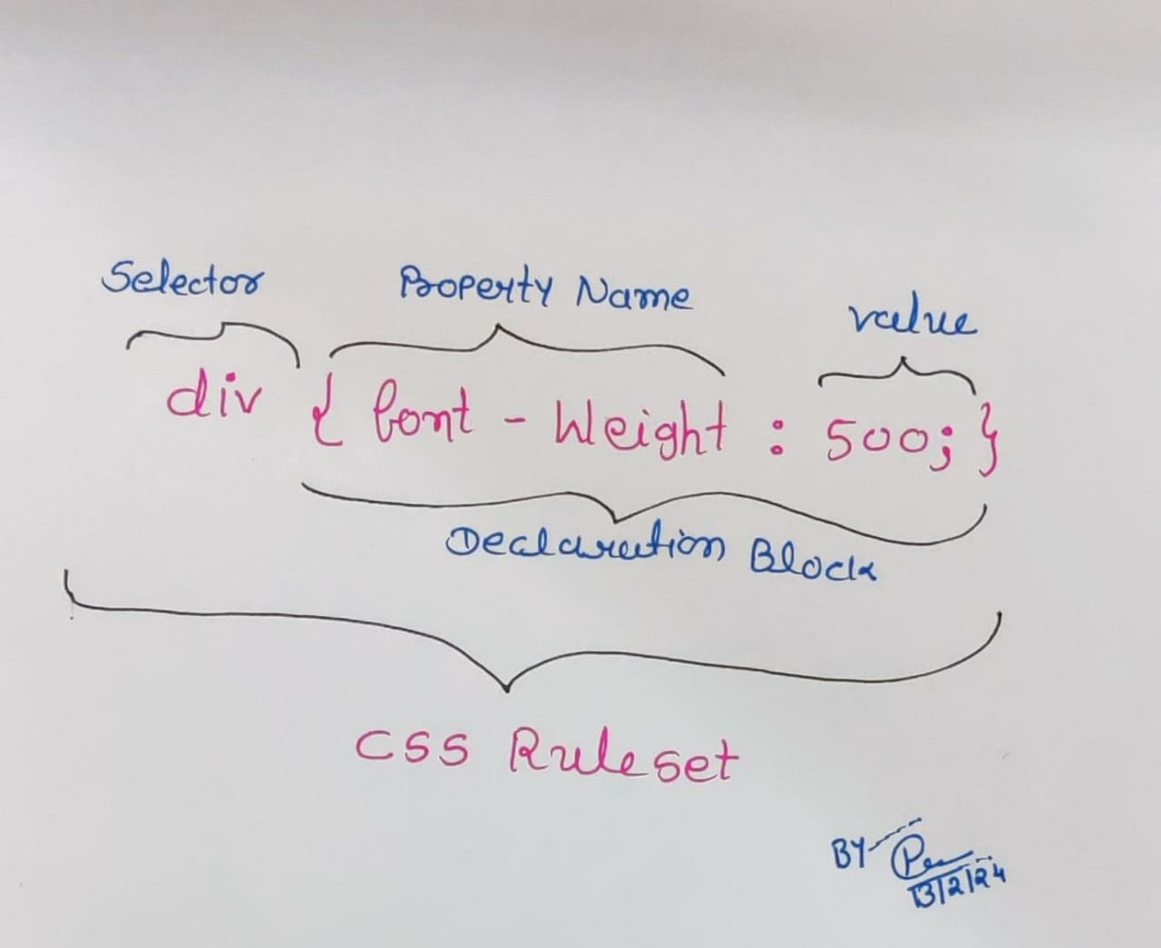**Ans.19** A **CSS ruleset** consists of an element selector and a properties declaration block.

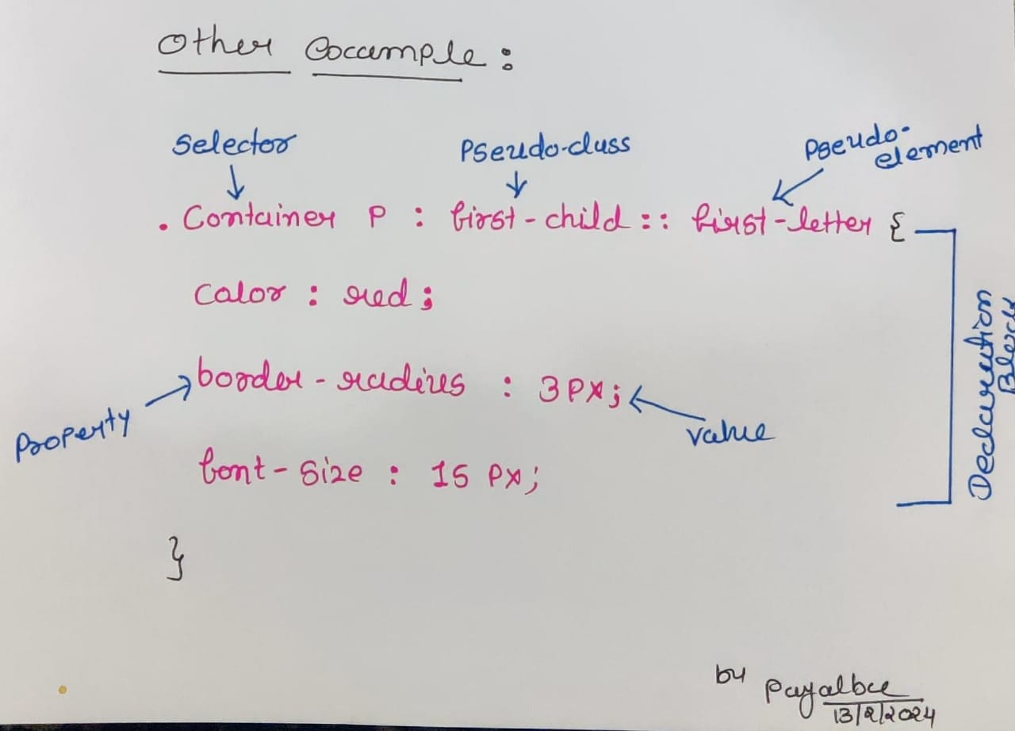

* A selector selects [HTML elements](https://codesweetly.com/web-tech-terms-h#html-element).
* A declaration block ({...}) groups one or more CSS declarations separated by semicolons (;).
* A CSS declaration consists of a CSS property name and value separated by a colon (:).
* It is best to use a semicolon after each declaration (including the last one) to prevent forgetting to add it in the future when adding more properties.

**Que.20 Create Layouts**

**Ans.20** below code for Nature Environment Layout :

<!DOCTYPE html>

<html lang="en">

<head>

    <meta charset="UTF-8">

    <meta http-equiv="X-UA-Compatible" content="IE=edge">

    <meta name="viewport" content="width=device-width, initial-scale=1.0">

    <link rel="stylesheet" href="https://cdnjs.cloudflare.com/ajax/libs/font-awesome/4.7.0/css/font-awesome.min.css">

    <title>Layout</title>

    <style>

        * {

            margin: 0;

            padding: 0;

        }

        /**

 * ----------------------------------------

 * Header Style

 * ----------------------------------------

 */

        .head {

            text-align: center;

            font-size: 30px;

            background-color: rgb(89, 177, 89);

        }

             /**

 * ----------------------------------------

 *Navigation bar Stle

 * ----------------------------------------

 */

        .nav1 {

            background-color: rgb(167, 142, 190);

            width: 100%;

        }

        .list1 {

            display: flex;

            list-style: none;

            font-size: 20px;

            font-weight: bold;

            padding: 10px;

        }

        .list1 a {

            text-decoration: none;

            /*background-color: aqua;*/

            padding-left: 30px;

            padding-right: 30px;

        }

        /**

 * ----------------------------------------

 * Create two unequal columns

 * ----------------------------------------

 */

        .main {

            display: flex;

        }

        /* Left column */

        .leftcolumn {

            float: left;

            width: 75%;

        }

        /* Right column */

        .rightcolumn {

            float: left;

            width: 25%;

            background-color: #f1f1f1;

            padding-left: 20px;

        }

              /**

 * ----------------------------------------

 * Footer Style

 * ----------------------------------------

 */

        .footer {

            text-align: center;

            color: rgb(22, 22, 22);

            font-size: 25px;

            background-color: rgb(89, 177, 89);

        }

           /**

 * ----------------------------------------

 * Social Media Icon

 * ----------------------------------------

 */

        .follow {

            text-decoration: none;

        }

/**

 * ----------------------------------------

 * animation text-blur-out

 * ----------------------------------------

 */     .text-blur-out {

                color: blue;

                font-size: 30px;

                text-align: center;

                animation: text-blur-out 1.2s cubic-bezier(0.550, 0.085, 0.680, 0.530) 1s infinite both;

        }

@keyframes text-blur-out {

  0% {

            filter: blur(0.01);

  }

  100% {

            filter: blur(12px) opacity(0%);

  }

}

/**

 * ----------------------------------------

End the Style Sheet

 * ----------------------------------------

 */

    </style>

</head>

<body>

    <!--Header-->

    <header class="head">

        <h1> Nature Environment Layout</h1>

    </header>

    <!--Navigation baar-->

    <nav class="nav1">

        <div class="div1">

            <ul class="list1">

                <li><a href=""> Home </a></li>

                <li><a href=""> About</a></li>

                <li><a href=""> Photo Gallery</a></li>

                <li><a href=""> Contact</a></li>

            </ul>

        </div>

    </nav>

    <!--Two Coloumn-->

    <div class="main">

        <!--First Coloumn-->

        <div class="leftcolumn">

            <h1> Save The Environment</h1>

            <img src="nature.jpg" width="800px" height="400px">

            <p>

                Nature can refer to the general realm of living plants and animals, and in some cases to the processes associated with inanimate objects— the way that particular types of things exist and change of their own accord, such as the weather and geology of

                the Earth. During the advent of modern scientific method in the last several centuries, nature became the passive reality, organized and moved by divine laws. With the Industrial revolution, nature increasingly became seen as the part

                of reality deprived from intentional intervention: it was hence considered as sacred by some traditions (Rousseau, American transcendentalism) or a mere decorum for divine providence or human history.

            </p>

            <img src="nature3.jpg" width="800px" height="400px">

            <p>

                Nature is sending us a message with the coronavirus pandemic and the ongoing climate crisis, UN’s environment programme chief, told Guardian.

            </p> <br><br>

             <!--Text Blur Animation-->

            <div class="text-blur-out">

                <h1>Go Green Breath Clean</h1>

            </div>

        </div>

         <!--Second Coloumn-->

        <div class="rightcolumn">

            <h1> About</h1>

            <p>In nature, nothing is perfect and everything is perfect. Trees can be contorted, bent in weird ways, and they're still beautiful

            </p>

            <div>

                <img src="nature2.jpg" width="250px">

                <p>Look into the nature, and then you will <br> understand everything.</p>

            </div>

            <br>

            <div>

                <img src="nature4.jpg" width="250px">

                <p>Every flower is a soul blossoming in the nature.</p>

                <br>

            </div>

            <br>

            <div>

                <img src="nature5.jpg" width="250px">

                <p>Ithink having land and not ruining it is the most beautiful art that anybody could ever want</p>

                <br>

            </div>

        </div>

    </div>

    <!--Footer-->

    <div class="footer">

        <h1> "Nature is not a place to visit. It is home."</h1>

        <div>

            <a href="" class="follow"> Follow :

                <i class="fa fa-facebook" style="font-size:35px;color:rgb(76, 154, 180);"></i> &nbsp;

                <i class="fa fa-instagram" style="font-size:35px;color:rgb(151, 51, 98);"></i>

        </div>

    </div>

</body>

</html>